|  |
| --- |
| Circle Language Spec: Commands |

## Procedure

The implementation of a command is called a procedure. The implementation of a command are all the private contents of a command. So the private contents of a command are called the procedure of a command.

### Diagram Notation

The term *procedure* is already defined in the article *Procedure*. The current article only shows the concept in a diagram.

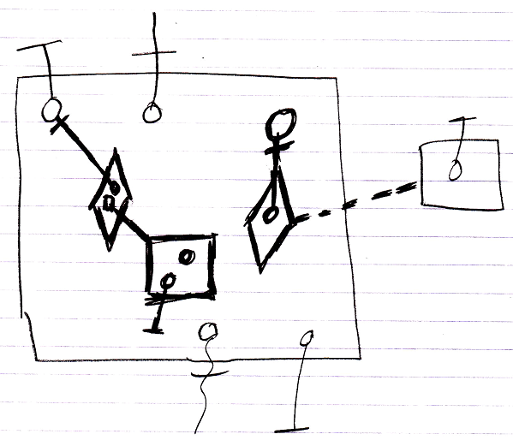

The contents of the large square, drawn with thick lines, are the command’s *procedure*, because they are all private contents The objects contained inside the large square, that are drawn with normal lines, are the command’s parameters.